**Database Creation**

CREATE DATABASE IF NOT EXISTS task6_sales;

USE task6_sales;

CREATE TABLE online_sales (

order_id INT,

order_date DATE,

product_name VARCHAR(100),

quantity INT,

price DECIMAL(10, 2)

);

SELECT COUNT(*) FROM online_sales;

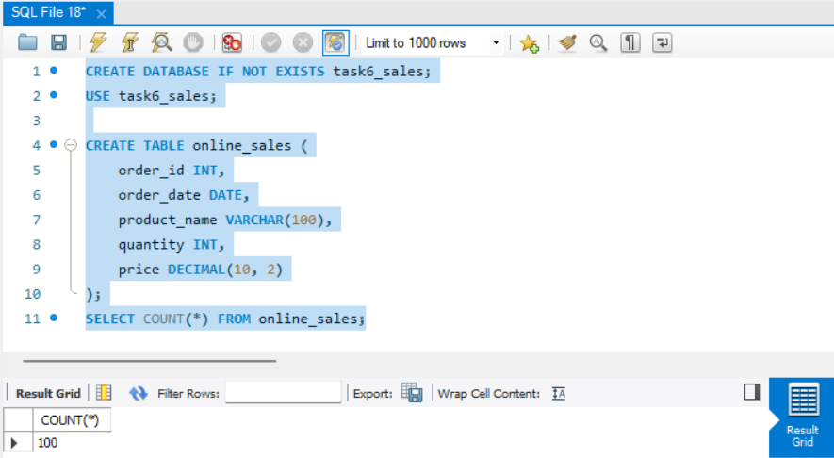

**✅ Query 1: Total Sales Amount**

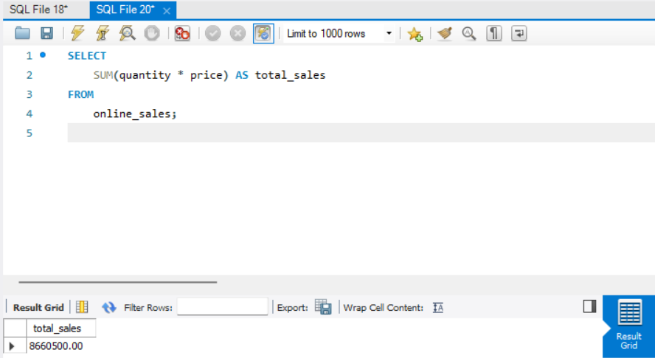

SELECT

SUM(quantity * price) AS total_sales

FROM

online_sales;

📌 **Insight:** This query calculates the total revenue generated from all online sales. It multiplies quantity with price for each record and sums them up.

**✅ Query 2: Total Orders**

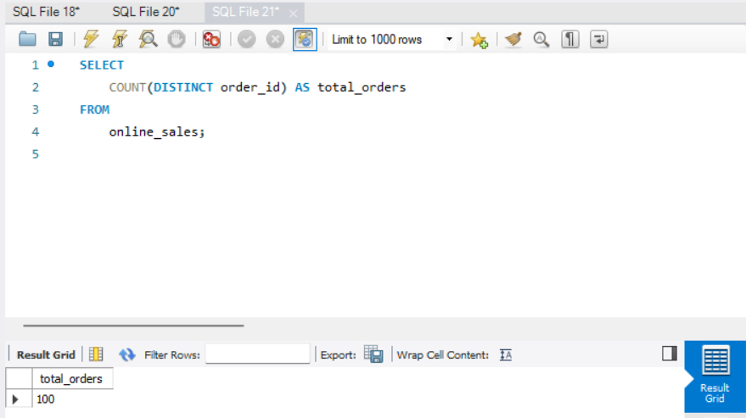

SELECT

COUNT(DISTINCT order_id) AS total_orders

FROM

online_sales;

📌 **Insight:** This gives the number of unique orders in the dataset. Helps understand the volume of transactions.

**✅ Query 3: Total Quantity Sold**

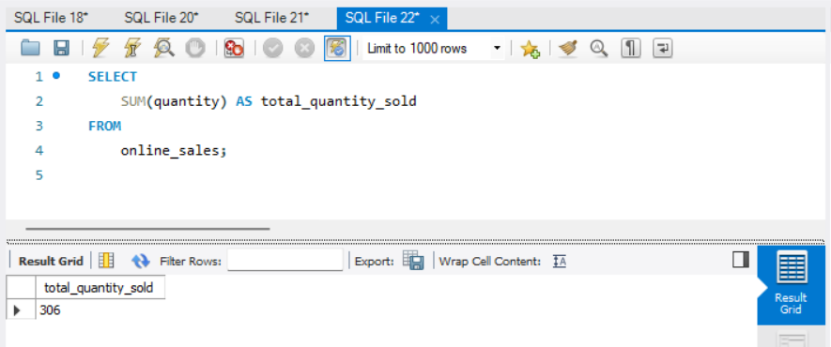

SELECT

SUM(quantity) AS total_quantity_sold

FROM

online_sales;

📌 **Insight:** This query shows how many total items were sold. Useful for inventory or sales volume analysis.

**✅ Query 4: Sales by Product**

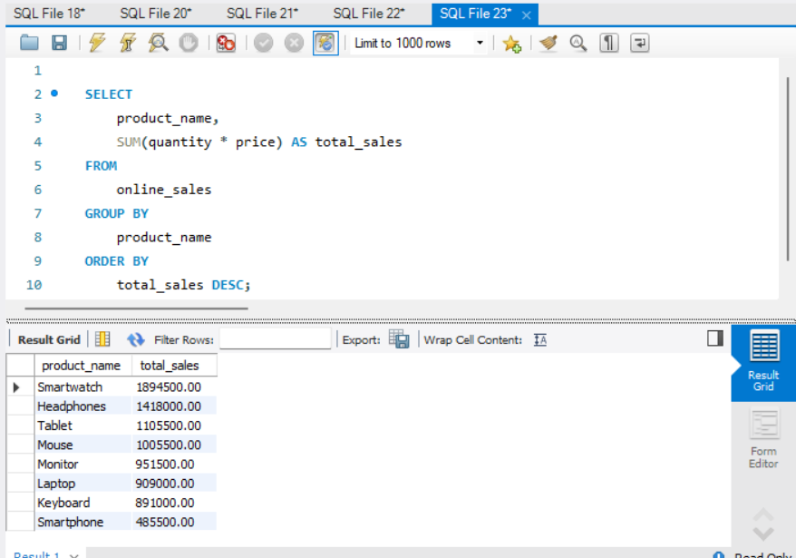

SELECT

product_name,

SUM(quantity * price) AS total_sales

FROM

online_sales

GROUP BY

product_name

ORDER BY

total_sales DESC;

📌 **Insight:** This shows which products generated the most revenue. Use it to identify top performers.

**✅ Query 5: Most Sold Product (by Quantity)**

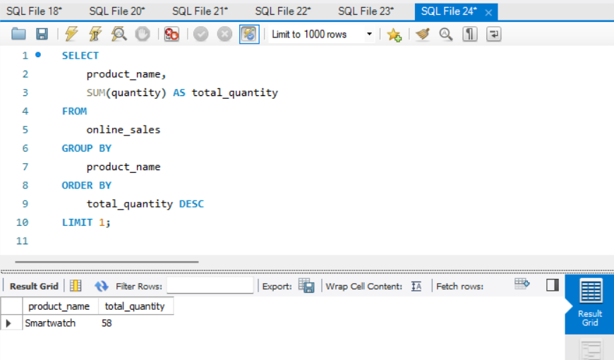

SELECT

product_name,

SUM(quantity) AS total_quantity

FROM

online_sales

GROUP BY

product_name

ORDER BY

total_quantity DESC

LIMIT 1;

📌 **Insight:** Finds the most sold product based on quantity. It might not be the most profitable but is in high demand.

**✅ Query 6: Monthly Sales Trend**

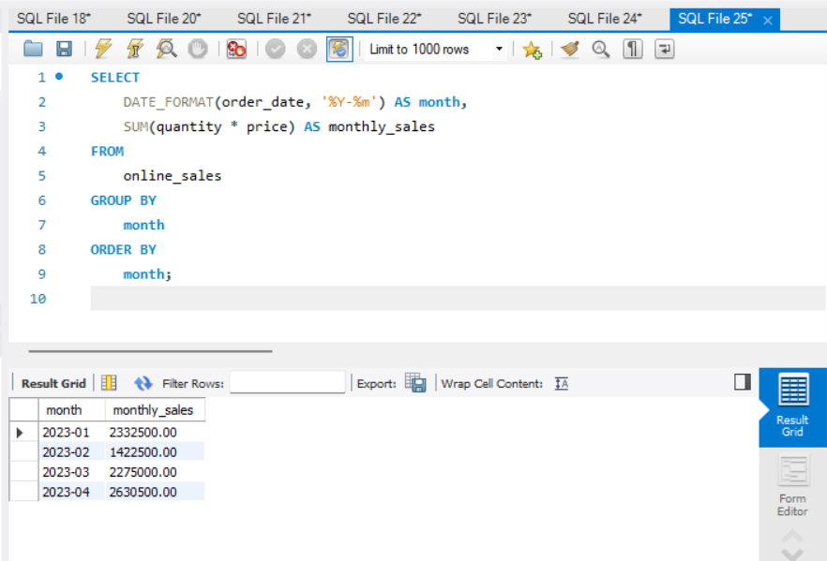

SELECT

DATE_FORMAT(order_date, '%Y-%m') AS month,

SUM(quantity * price) AS monthly_sales

FROM

online_sales

GROUP BY

month

ORDER BY

month;

📌 **Insight:** Shows month-wise total sales, useful to identify sales trends over time.

**✅ Query 7: Daily Orders**

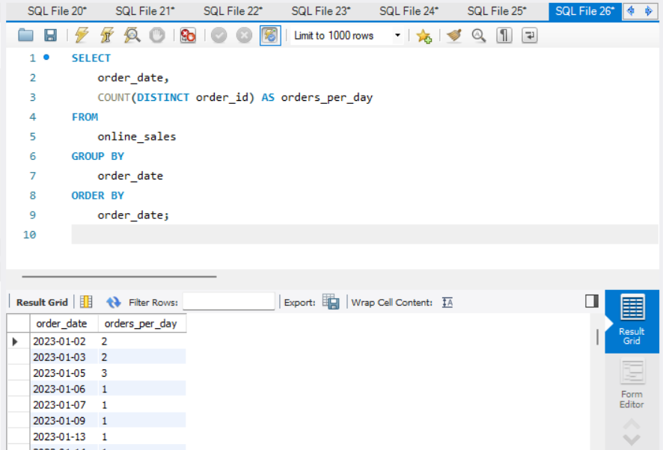

SELECT

order_date,

COUNT(DISTINCT order_id) AS orders_per_day

FROM

online_sales

GROUP BY

order_date

ORDER BY

order_date;

📌 **Insight:** This helps to analyze daily activity — can spot busy vs. slow days.

**Query 8: Top 3 Months by Revenue**

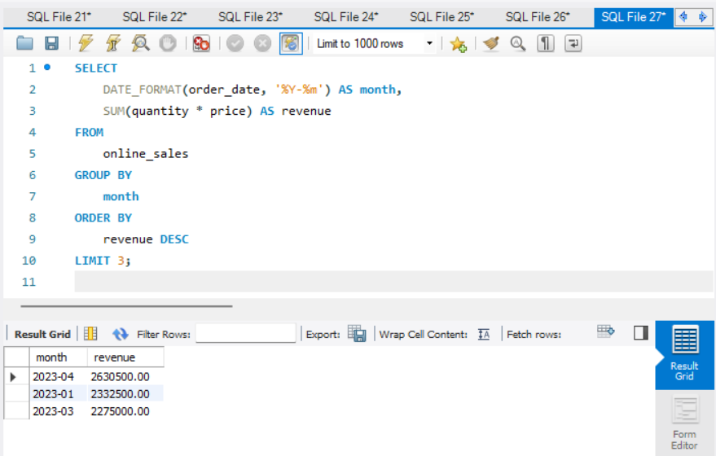

SELECT

DATE_FORMAT(order_date, '%Y-%m') AS month,

SUM(quantity * price) AS revenue

FROM

online_sales

GROUP BY

month

ORDER BY

revenue DESC

LIMIT 3;

📌 **Insight:** This shows the top 3 months where sales were highest. Very helpful for identifying peak business periods.

**Query 9: Using EXTRACT**

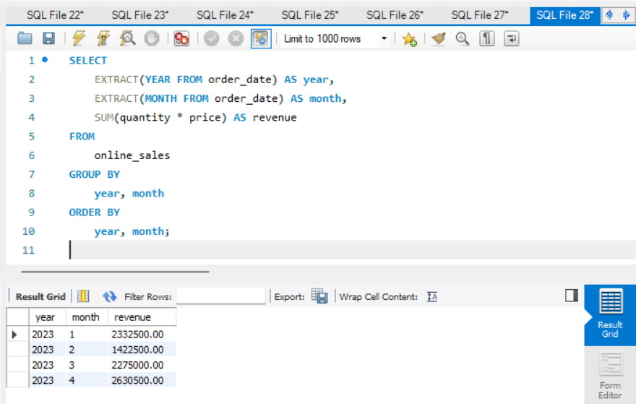

SELECT

EXTRACT(YEAR FROM order_date) AS year,

EXTRACT(MONTH FROM order_date) AS month,

SUM(quantity * price) AS revenue

FROM

online_sales

GROUP BY

year, month

ORDER BY

year, month;

📌 **Insight:** This query breaks sales down by year and month using SQL's EXTRACT() function.